MyAnimeList

Definition
# Source: ScreenShots Source: Provided by: [Persons Table -> ID Column: 1, Name_En Column: Motasem Essam] -> Tool: [Lightshot Program] -> From [Site: https://myanimelist.net] on [10/29/2025]
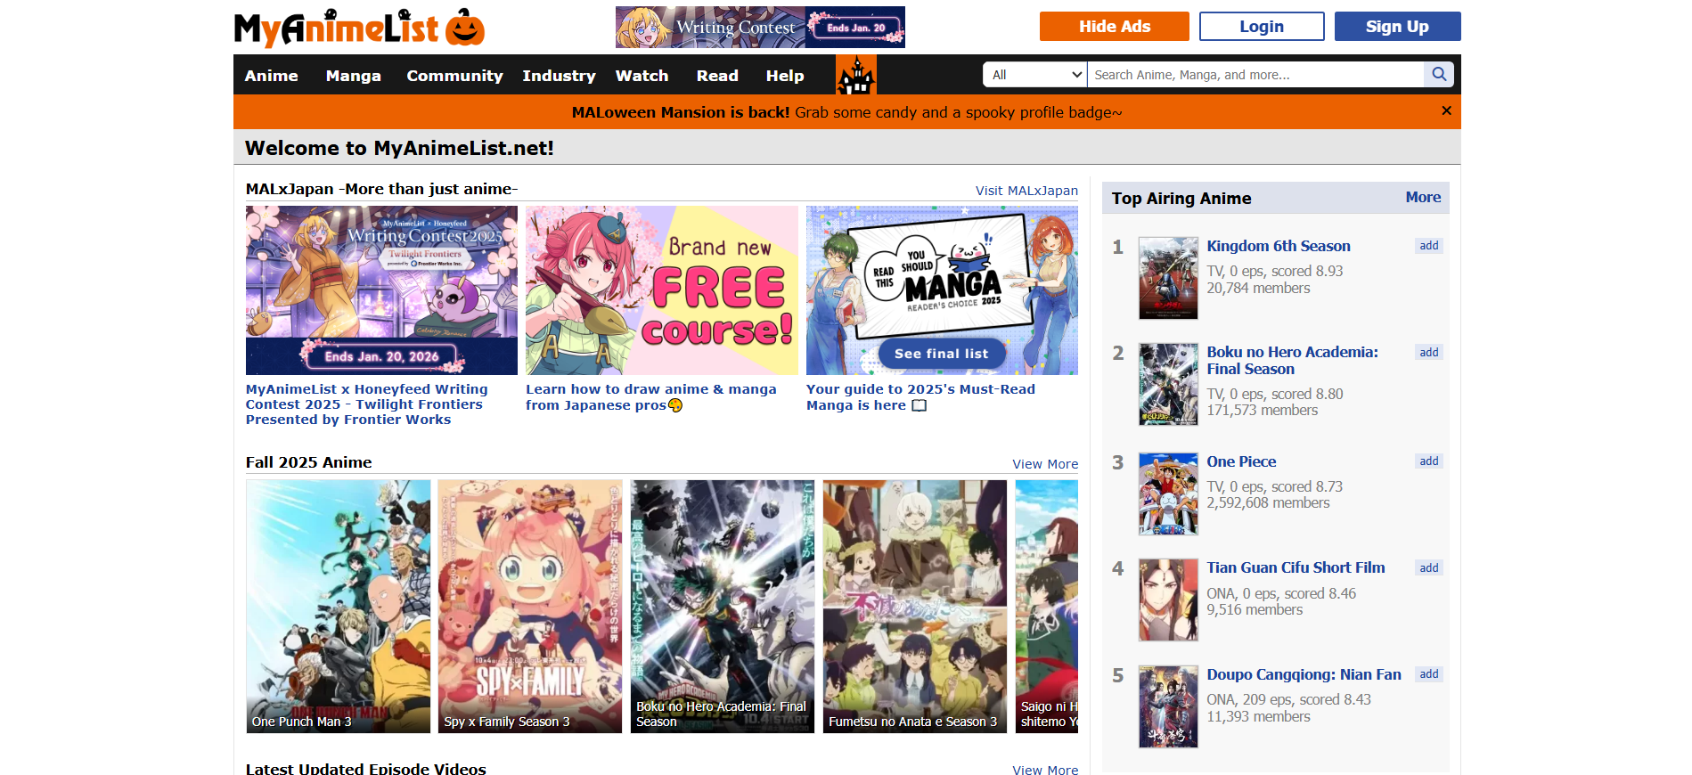
# Source: AI Source: Provided by: [Data Path: Persons Table -> ID Column: 1, Name_En Column: Motasem Essam] -> From: [ChatGPT] on [10/29/2025]
MyAnimeList (MAL) is a popular online database and community platform for anime and manga. It was launched in 2005 and has become one of the largest resources for fans worldwide.
- Website: https://myanimelist.net
- Languages: Mainly English and Japanese, with some community translations.
- Purpose: Track, organize, and discover anime and manga while connecting with a fan community.

Key Features
# Source: AI Source: Provided by: [Data Path: Persons Table -> ID Column: 1, Name_En Column: Motasem Essam] -> From: [ChatGPT] on [10/29/2025]
a) Database
- Contains detailed information about anime and manga titles.
- For manga, it includes:
  - Title (English, Japanese, synonyms)
  - Author & artist
  - Publisher
  - Genres (action, romance, shonen, seinen, etc.)
  - Synopsis / summary
  - Number of volumes and chapters
  - Status (ongoing, finished, hiatus)
  - Release dates
b) Volumes & Chapters
- Lists volume count for manga series.
- Sometimes includes brief summaries of each volume.
- Occasionally shows cover images of volumes (mainly official releases).
c) User Tracking
- Users can create a personal “Manga List” or “Anime List”.
- Track which series they have:
  - Completed
  - Currently reading/watching
  - Plan to read/watch
- Users can rate series (1–10) and write reviews.
d) Community
- Forums and discussion threads for:
  - Recommendations
  - Episode/chapter discussions
  - Fan theories and analysis
- Users can add reviews, recommendations, and ratings to help others.
e) Seasonal Charts
- Lists current and upcoming anime by season.
- Shows airing dates, episode count, and staff info.
f) Extras
- News articles about anime/manga industry.
- Character and staff databases.
- Recommendations engine: suggests new anime/manga based on your list.

Example Usage
# Source: AI Source: Provided by: [Data Path: Persons Table -> ID Column: 1, Name_En Column: Motasem Essam] -> From: [ChatGPT] on [10/29/2025]
- Want to know how many volumes a manga has? → Check the MAL manga page.
- Want to see volume cover images? → Scroll through the “Volumes” section.
- Want to track your reading progress? → Add series to your personal MAL list.

Summary
# Source: AI Source: Provided by: [Data Path: Persons Table -> ID Column: 1, Name_En Column: Motasem Essam] -> From: [ChatGPT] on [10/29/2025]
MAL is both a reference database and a community hub for anime and manga fans. It is ideal for:
- Checking series info, authors, genres, and volumes.
- Viewing cover images and summaries.
- Tracking your personal reading/watching progress.
- Reading and writing reviews or joining discussions.

